Your DevOps Roadmap (Correct Order)
Follow this order — this is how real companies build it.
1️⃣ Containerization (DONE)
Docker + Compose

2️⃣ CI Pipeline (NEXT STEP)
GitHub Actions
Build images
Push to Docker Hub

3️⃣ Kubernetes Deployment
Create:
- Deployment
- Service
- ConfigMap
- Secret
- Ingress
Deploy app to cluster.

4️⃣ Cloud Infrastructure (Terraform)
Provision infrastructure:
- AWS VPC
- EKS Cluster
- Node Groups
- Load Balancer
Everything automated.

5️⃣ Configuration Management
Use Ansible for:
- server provisioning
- cluster setup
- system packages

6️⃣ GitOps (Advanced Stage)
Use:
- ArgoCD
- Flux
Flow becomes:
Git → ArgoCD → Kubernetes
Auto deployments from Git.

7️⃣ Monitoring & Observability
Add:
- Prometheus
- Grafana
- Loki
- Alertmanager

🔥 The Correct DevOps Pipeline
Your final architecture will look like this:
Developer
│
▼
GitHub
│
▼
GitHub Actions (CI)
│
▼
Docker Hub (Images)
│
▼
Terraform → AWS Infrastructure
│
▼
Kubernetes Cluster
│
▼
ArgoCD (GitOps CD)
│
▼
Application Running

First I create a docker file of fornetend
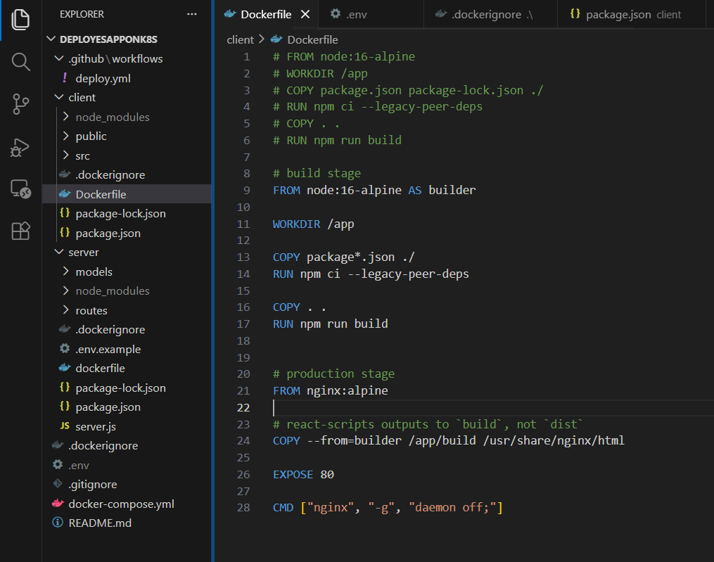

Then I create a docker file of server or backend
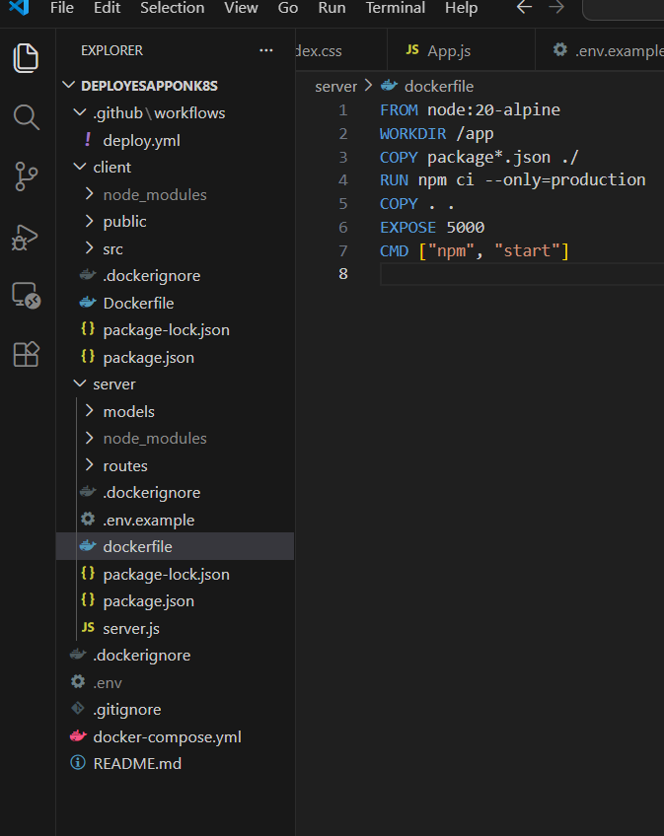

Then I setup docker compose file
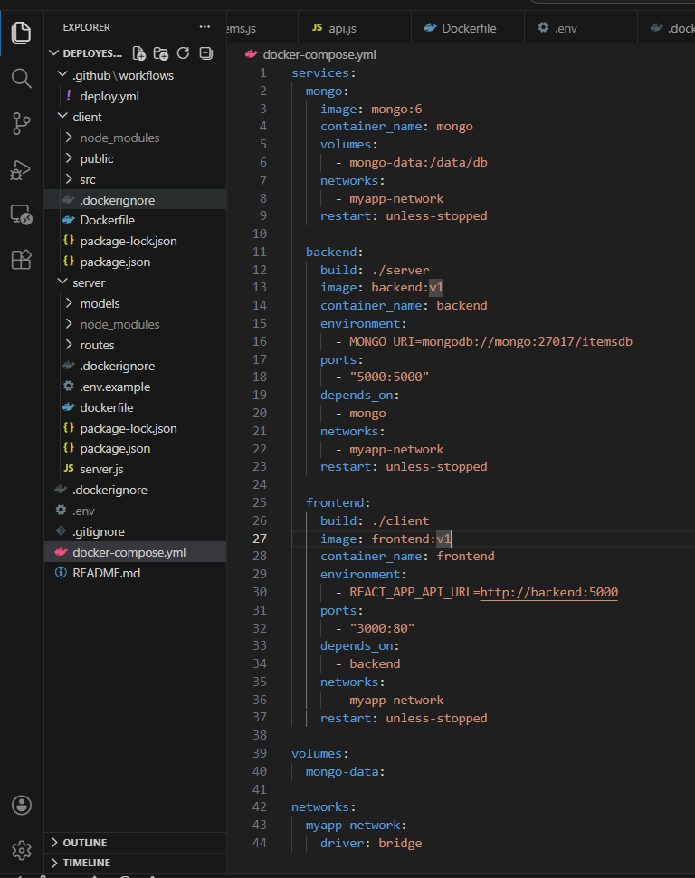

Some command to run it loocalyy on docker
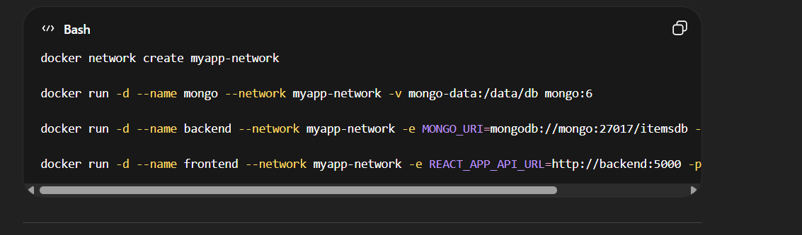

Then I created github action file and first create docker hun secrtes and then setip pipline and then push it to docker hub this all done in pipline

